Assignment 1: General UNIX Utilities

**Weight**: 15% of your final grade

**Due**: after Unit 2, Section 1 (ideally by the end of Week 4)

**General Notes**

For Assignment 1, you are going to complete the following learning activities taken from your textbook. Use the script command to save the terminal session wherever necessary. Saving the terminal starts with the **script**filename command and ends with **exit**.

Combine all required problems in this set in one file, name it COMP325_1_YYMM (replacing ‘YYMM’ with the current year and month, e.g., 1309), **and upload it here to submit it to your tutor for marking and feedback.**

* Be sure to complete the final step—click on the **Send for Marking** button to notify your tutor.

1. Solve problems 7–11 and 15–17 at the end of Chapter 7.

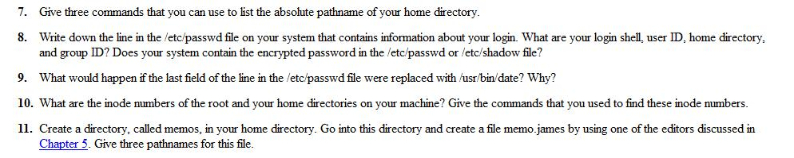

7.echo $HOME; pwd -P ~;

8.root:x:0:0:root:/root:/bin/bash

login shell:/bin/bash user ID:0; group ID:0;home directory:/root

The password is encrypted and in the /etc/shadow

9.can't login the user anymore, because linux use the field is not exist

10.The number of the inode is 4541160,the home directory is /root;

The command is df -i

11.mkdir memos; touch memo.james

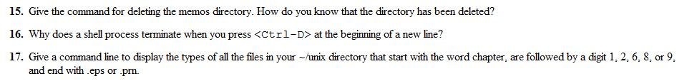

15.rm -rf memos; ls -al, can't see it anymore

16.CTRL_D is just a signal saying that this is the end of a text stream

17.ls -al | grep -E 'chapter(1|2|6|8|9).(eps|prn)'

1. Solve problems 7–17 at the end of Chapter 8.

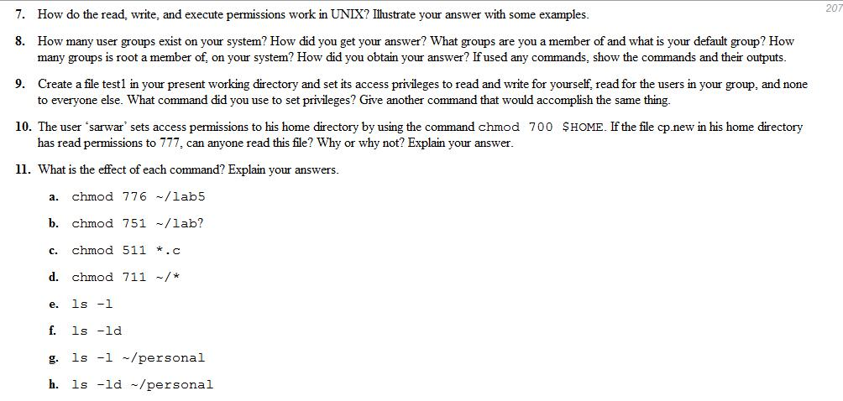

7.use rwx to control the permissions, r=4,w=2,x=1

8. 57;use command “cat /etc/group|wc”;root, default is root

9.touch file1;chmod 640 file1;chmod u=rw,g=r ,o= file1

10.only sarwar and root user can read the file, because only the home directory owner have access to it.

11.a.owner,group user can read, write and execute the file,other group user can read, write the file, but can’t execute the file

b. owner user can read, write and execute the file la or lab;group user can write and execute the file la or lab; other group user can execute the file la or lab

c.owner user can write and execute files end with .c; group user and other group user can execute the files end with .c;

d. owner user can read, write and execute all the files in home directory; group user and other group user can execute files in home directory.

e.list the files and directories in current directory use a long listing format

f. list the directoies in the current dictory

g. list the files in the ~/personal directory

h. list the files and directories in the ~/personal directory

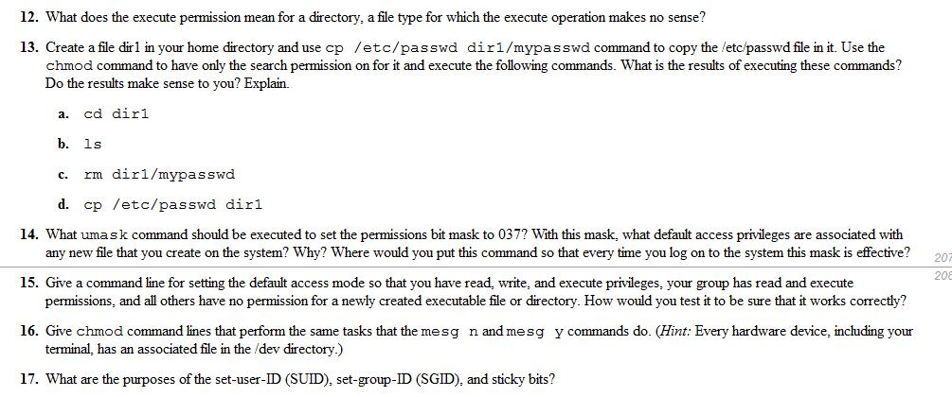

12.It means that user can search the directory, can enter the directory

13. a.enter directory dir1

b.do not have permissions

c.can’t remove, do not have permission

d.can’t make file dir1/passwd, do not have permission

14.umask 037, the privileges of the new files is 740, because system use (777-mask) as the default privilege; put the command in ~/.profile or ~/.login or /etc/profile

15.umask 027; to the the command, make new file with different use and group,the list the file to see the permission.

16.chmod a+w /dev/pts/1 for mesg n; chmod a-x /dev/pts/1 for mesg y

17.suid: set access rights flags that allow users to run an executable with the permissions of the executable's owner;sgid: set access rights flags that allow users to run an executable with the permissions of the executable's group respectively; sticky bits: When a directory's sticky bit is set, the filesystem treats the files in such directories in a special way so only the file's owner, the directory's owner, or root user can rename or delete the file.

1. Do problem 9 (What do the following commands do?) in Chapter 9.

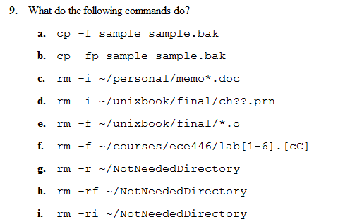

* 1. copy file sample to sample.bak
  2. copy file sample to sample.bak with specified attributes
  3. prompt user to remove any files starts with memo and ends with .doc in personal directory
  4. prompt user to remove any files starts with ch and ends with .prn, two chars between them, in ~/unixbook/final/
  5. remove files ends with .o in ~/unixbook/final
  6. remove files ends with .o or.C, begins with lab and 1 to 6 next in ~/courses/ece446/lab[1-6].[cC]
  7. remove the directory in the ~/NotNeededDirectory , including all the files and directory included
  8. remove the directory in the ~/NotNeededDirectory , including all the files and directory included
  9. prompt to user to remove the directory in the ~/NotNeededDirectory , including all the files and directory included

1. Enter a C program that reads a temperature in Celsius entered from a keyboard and displays the corresponding temperature in Fahrenheit and complete the steps below. (*Hint:*Look for such a program in the textbook or online.)

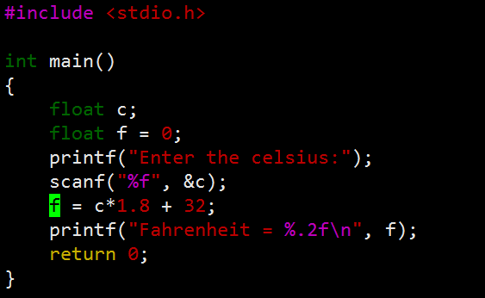

1. Compile this program using the cc compiler, or any other compiler.  Fix any errors, and recompile.

gcc transform.c

1. Your program must have declaration statements, such as *float c, f;* . Delete the semicolon from the end of the statement.  Recompile and report the kind of error.  The C compiler often provides cryptic error messages. Interpret this message.

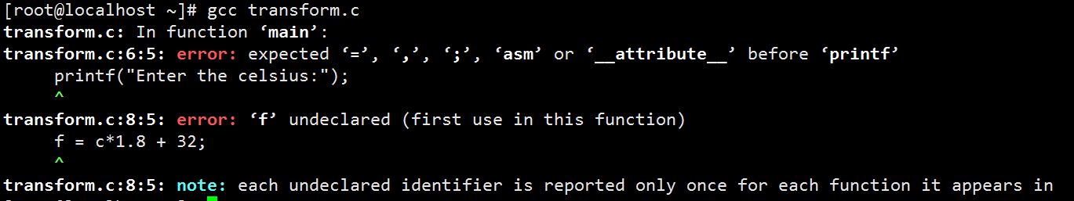

Lack of ; before printf

1. Change the *float c, f;* statement to (*float c; char f;).*Do you get any errors during compilation? What are they and why? Do you see any difference between running this program and the earlier version? Why?

Yes, c and f are undeclared, in the earlier version, c is declared, becase there is a ‘,’ behind c.

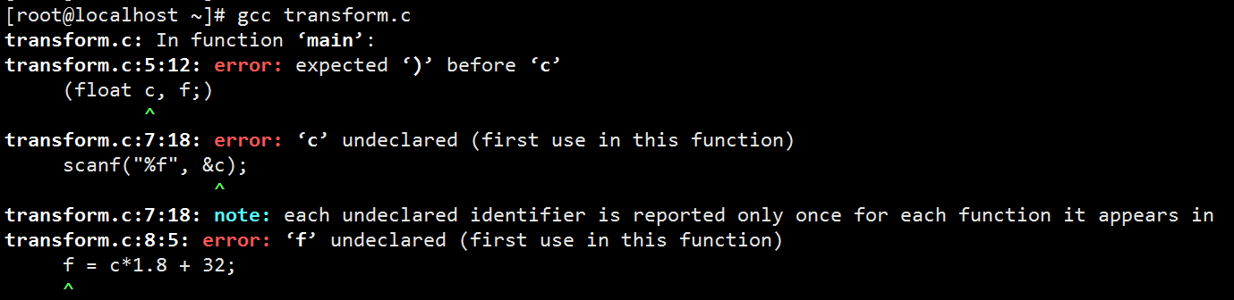

1. If your program uses a *cout*statement, then replace it with a *printf*  statement that does the same thing and vice versa. If you have used neither  *cout* nor *printf* in the first version, then replace what you have with *printf*.

Done in the program

1. Explain how you can schedule the executable program to run at 1:00 a.m. and to take the input from a file, rather than the keyboard, without any changes to the source program.  
   use crontab and IO redirection

Add a new job

0 1 * * * /root/a.out < 12

1. Explain how you can find the time it took the computer to execute your program.

Use command time ./a.out

1. Explain how the output of your program can be automatically emailed to your friend upon completion.

./a.out | mail -s "finished" friend@xx.com